MACRO DESCRIPTION
a macro that will let you in after correct login or password entered.
Inside you will be able to choose last report (in .txt format) to upload. Your login define your role and report categories that you can choose to upload.
After text implementation you have to update data with current date, and calculate basic price rates.
Received result will be saved automatically as final report wtih .csv extension
After all the data should be cleared in Active sheet, so you could upload next report at the same place as before.

1 Step: creating form automatically showed after Workbook will be opened
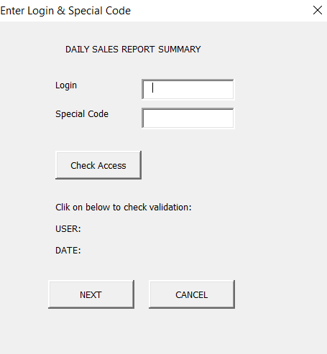
Code inside:

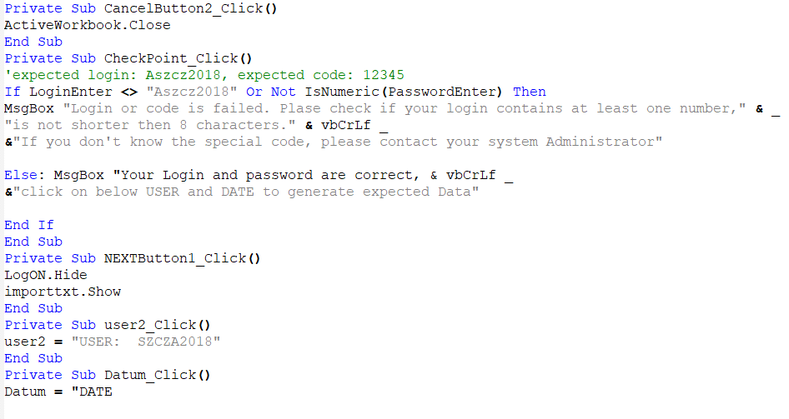

Login and Special Code entered properly:
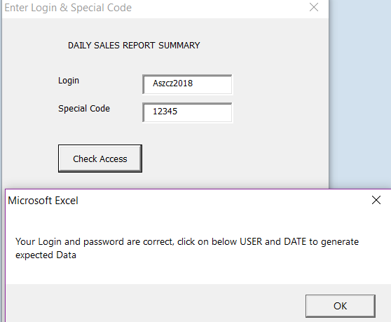
Login wrong entered:
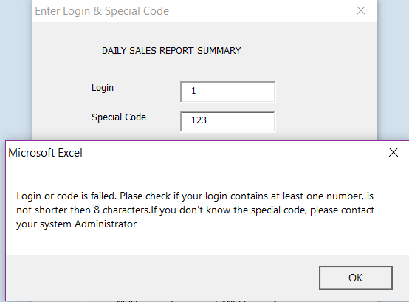
Generating automatic user number and date of log into system:
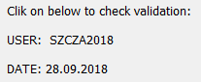
By clicking on 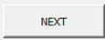 we will open next form to import data from .txt file

Step2: Import data from text file and generate final report
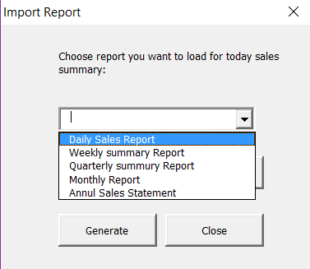
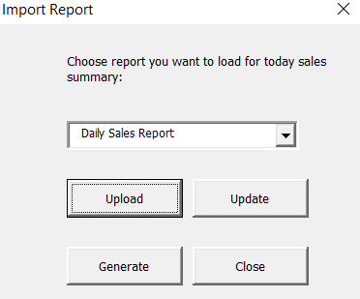
Inside Code:
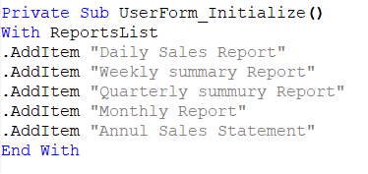
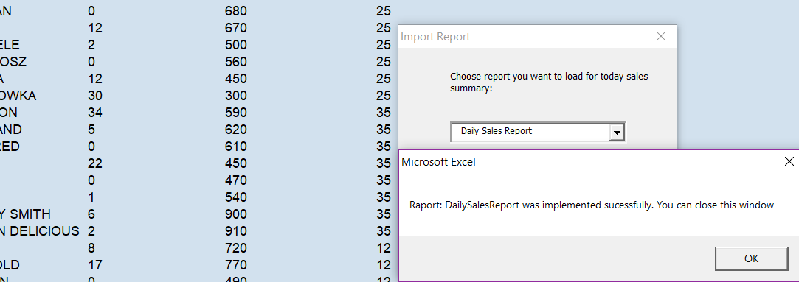

Inside code:
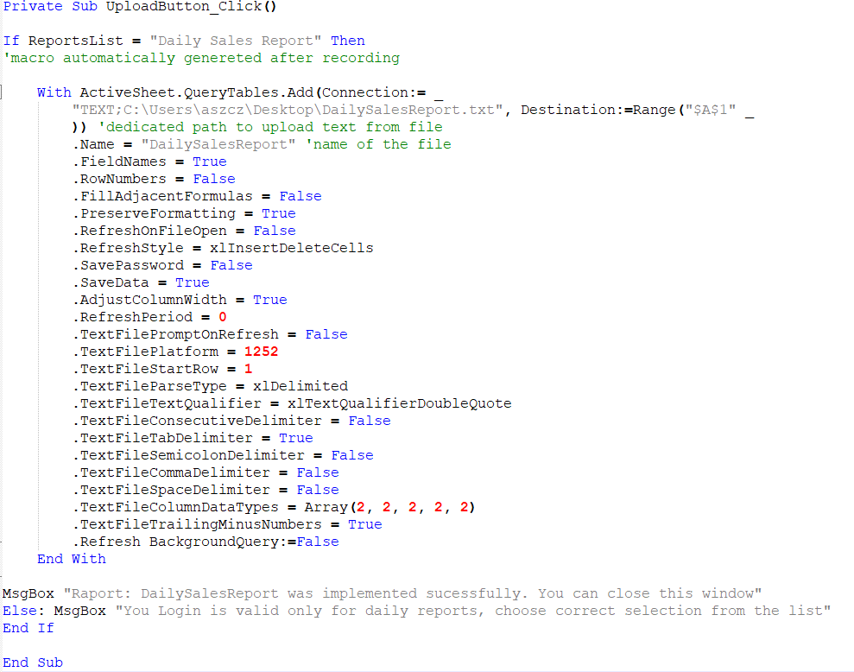
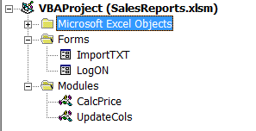

Modules with procedures that will be called in form Import Report
Module: UpdateCols

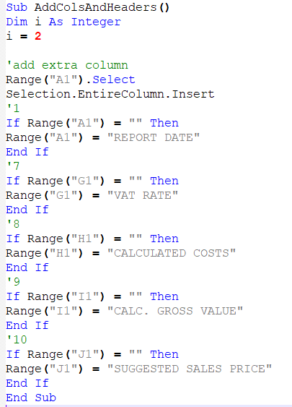

Module: CalcPrice

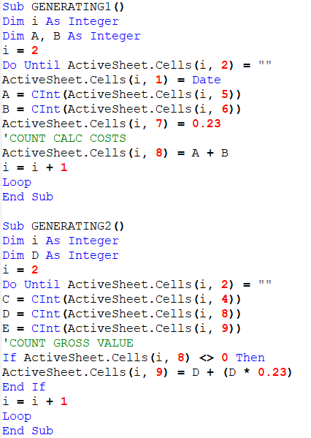
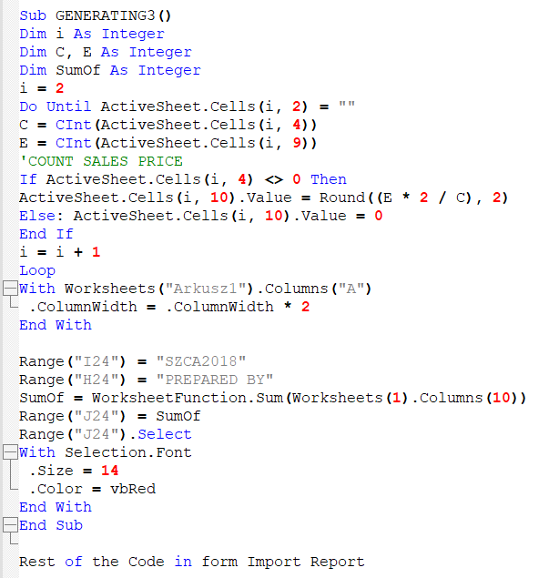

Rest of the Code in form Import Report

